SCUBA-2 Block Specification
reply_translator

February 15, 2005
Table of Contents

1. Block Overview 3
1.1 Block Location and Block Interface Within System 3
1.2 Overview of reply structure and data structure 4
1.3 Overview of command procedures 6
1.3.1 ‘GO’ Command (start_application) 6
1.3.2 ‘RS’ Command (reset) 6
1.3.3 ‘RB’ Command (read_block memory) 6
1.3.4 ‘WB’ Command (write_block memory) 7
1.3.5 ‘ST’ Command (stop_application) 7
1.4 Overview of block 8
1.4.1 Block operations 8
1.5 Block Dataflow 10
2. Block Interfaces 11
2.1 Interface Signal Description 11
2.2 Interface Protocol and Timing 13
3. High-Level Description 14
3.1 State Machine Description 14
4. Files of the Block 16
4.1 Source Code 16
4.1.1 reply_translator.vhd 16
4.2 Header Code 16
4.2.1 issue_reply_pack.vhd 16

Block Overview

This main function of this block is to construct fibre packets and write them as a little-endian byte stream to the transmit fifo fibre_tx_fifo. There are two types of fibre packets that reply_translator handles: command reply packets, and data frame packets.

Block Location and Block Interface Within System
As illulstrated in Figure 1, reply_translator is part of the issue_reply block. This is located on the clock card FPGA. Specifically reply_translator interfaces with the following blocks:

- fibre_tx
- reply_queue
- cmd_translator

to fibre
from fibre
fibre_rx
…
frame #
macro seq#
macro instr
cmd_translator
cmd_queue
macro seq#
μ seq#
μ instr
0
rp→
ip→
rp→
ip→
rp→
ip→
1
2
bus_tx (LVDS)
bus_rx (LVDS)
bus_rx (LVDS)
from AC
from BC
from CC
reply_queue
reply_translator
fibre_tx
1
3
2
8
4
6
7
:
:
ack
5
Figure 1: Issue_reply

Overview of reply structure and data structure
This section provides a brief overview of the command reply structure and data structure.
There are five fibre commands namely ‘read_block memory’, ‘write_block memory’, ‘start_application’, ‘stop_application’, and ‘reset’. The structure of their replies to the host PC is shown in Table 1 (with the exception of a successful read_block memory command – which is discussed later).

(2X32 bits)  Preamble | (32 bit) | (32 bit) | (32 bit) | 2* (32 bit) |  | (32 bit)
0xA5A5A5A5  0x5A5A5A5A | “ RP”  0x20205250 | Packet size  (4) | Reply | Reply arguments |  | Checksum
Header1/2 | Header3 | header4 | Word1 | Word2 | Word3 | Word4

Table 1: Command Reply Structure (not read_memory block)

As shown there are four 32-bit header words followed by four 32-bit reply words. The packet size gives the number of 32-bit words in the packet (in this case 4). The header words stripped off by the PCI interface and are used to inform the linux PC of the nature and size of the packet.
The actual reply words are detailed in the tables below. Table 2 reveal the replies to successfully executed commands, while Table 3 reveals the replies when an error has occurred.
 | Success reply
 | Word 1 | Word2 | Word 3 | Word 4
Start_application | “GOOK“( 0x474F4F4B) | CardId+ ParaId | 0x0 | Checksum
Stop_application | “STOK”( 0x53544F4B) | CardId+ ParaId | 0x0 | Checksum
Reset | “RSOK” ( 0x52534F4B) | CardId+ ParaId | 0x0 | Checksum
Write_Block memory | “WBOK”( 0x57424F4B) | CardId+ ParaId | 0x0 | Checksum

Table 2: Replies to successfully executed fibre commands

 | Error reply
 | Word 1 | Word2 | Word 3 | Word 4
Start_application | “GO ER”(0x474F4552) | CardId+ ParaId | Error Number | Checksum
Stop_application | “STER”(0x53544552) | CardId+ ParaId | Error Number | Checksum
Reset | “RSER”(0x52534552) | CardId+ ParaId | Error Number | Checksum
Write_Block memory | “WBER”( 0x57424552) | CardId+ ParaId | Error Number | Checksum
Read_Block memory | “RBER” (0x52424552) | CardId+ParaId | Error number | Checksum

Table 3: Replies to fibre commands in error

As mentioned above, the reply to a successful read_block memory command takes a slightly different format. This is because the reply includes a block of N data words read from memory (where N is in the range 1 → 58). The reply structure is revealed in Table 4.

 | Success reply
 | word 1 | word 2 | word 3 to word N+2 | word N + 3
Read_Block memory | “RBOK” ( 0x52424F4B) | CardId+ParaId | N Data values | Checksum

Table 4: Reply to successful executed read_block memory command

The firmware must generate a standard format reply upon the completion of the command, with the exceptions of ‘reset’ and ‘start_application’, which generate replies before execution. Such standard replies indicate the success or failure of the command.

When a ‘start_application’ command is received by the firmware it must generate a reply to the command then execute the command. Furthermore, the execution of a ‘start_application’ command must always generate data. This data might be a frame/N frames of status information or may be a frame/N frames of pixel data. All data frame packets take the format shown it Table 5.

(2X32 bit)  Preamble | (32 bit) | (32 bit) | (N x 32 bits)  Frame block |  |  |  | (32bit)
0xA5A5A5A5  0x5A5A5A5A | “ DA”  0x20204441 | Packet size | Frame status | Frame Seq. number | Frame header words (retrieved form local RAM) | Frame Data words  read from fibre_word_i | Checksum
Header1/2 | Header3 | Header4 | Word1 | Word2 | Words…. | Words…. | WordM

Table 5: Data Frame Packet Format
As shown in Table 4, there are 4 packet header words (stripped off by the PCI interface) and M frame words. The first frame word is a status word used by the RTL software, and the second word is the frame sequence number. The next series of words are read from a local buffer, which contain the row order sequence and various other housekeeping data (this RAM is periodically updated by local commands). The next series of words are the pixel data read from reply_queue (via the fibre_word_i port), and the final word is the calculated checksum.

Overview of command procedures
This section describes the chain of events for each of the 5 permitted commands. Note that if any command arrives along the fibre with a checksum error, then fibre_rx, informs cmd_translator, which in turn informs reply_translator. Reply translator then writes an error reply to the transmit FIFO. If the MCE is running an application (returning frames of data), and a ST command arrives with a checksum error, reply_translator will finish transmitting the current frame of data then issue an error reply, then continue returning frames of data.

‘GO’ Command (start_application)

- When cmd_translator receives a GO command it notifies reply_translator.
- Reply_translator immediately issues a reply to the GO command (this is to acknowledge the receipt of the GO command to the RTL software, which in turn frees up the RTL camera task to issue a ST command if required). Note that the last word of the reply is the reply packet checksum.
- Meanwhile, the cmd_translator begins issuing ret_data maro_ops to run the application instigated by the GO command. The application must generate at least one data packet.
- When a data packet is ready reply_queue informs reply_translator.
- Reply_translator subsequently writes the appropriate data packet header to the transmit FIFO.
- Reply_translator then writes the frame status word, and frame sequence number to the transmit FIFO.
- Reply_translator then retrieves the rest of the frame header writes the frame status word, and frame sequence number to the transmit FIFO.

- Reply_translator then reads the data packet word by word from reply_queue, splitting each word up into four bytes and writing it little endian to the transmit FIFO.
- Finally reply_queue writes the data packet checksum to the transmit FIFO.
- Reply_translator then informs reply_queue that the data packet has been written to the transmit FIFO.

Steps 4 through to 8 are repeated for every data packet generated by the running application.

‘RS’ Command (reset)

- When cmd_translator receives a RS command it notifies reply_translator.
- Reply_translator immediately issues a reply to the RS command (reply packet written to the transmit FIFO).
- Meanwhile cmd_translator beings issuing the appropriate macro_ops to perform the reset.

‘RB’ Command (read_block memory)

- When cmd_translator receives a RB command it notifies reply_translator.
- Reply_translator ignores this notification.
- Meanwhile, the cmd_translator issues a maro_op to execute the command.
- Once completed (successfully or in error) reply_queue informs reply_translator.
- Reply_translator writes the appropriate reply packet header, and reply words 1 and 2 to the transmit FIFO. Each word is split up into four bytes and written little endian.
- Reply_tranlator then reads the read_block words (word 3 → N+2) from reply_queue. Each word is split up into four bytes and written little endian to the transmit FIFO.
- Reply_translator then writes the reply packet checksum to the transmit FIFO.
- Reply_translator then informs reply_queue that the reply packet transmission has been completed.

‘WB’ Command (write_block memory)

- When cmd_translator receives a WB command it notifies reply_translator.
- Reply_translator ignores this notification.
- Meanwhile, the cmd_translator issues a maro_op to execute the command.
- Once completed (successfully or in error) reply_queue informs reply_translator.
- Reply_translator writes the appropriate reply packet header, and reply words 1, 2 and 3 to the transmit FIFO. Each word is split up into four bytes and written little endian.
- Reply_translator then writes the reply packet checksum to the transmit FIFO.
- Reply_translator then informs reply_queue that the reply packet transmission has been completed.

‘ST’ Command (stop_application)
Note: this command is only ever issued while a data generating application is running.
- When cmd_translator receives a ST command it notifies reply_translator.
- Reply_translator ignores this notification.
- cmd_translator terminates issuing ret_data macro_ops and stacks a STOP macro op, which is used to generate the STOP reply.
- Reply_queue continues to inform reply_translator each time there is a data packet to be transmitted. The next one should be the last frame, but might not be depending on when the ST command is received in the readout cycle. The last frame is identified by the assertion of the input signal last_frame_i.
- Once the last frame data packet has been packaged up and written to the transmit FIFO by reply_translator, reply_queue informs it to send a STOP reply packet.
- Reply_translator writes the appropriate reply packet header, and reply words 1, 2 and 3 to the transmit FIFO. Each word is split up into four bytes and written little endian.
- Reply_translator then writes the reply packet checksum to the transmit FIFO.
- Reply_translator then informs reply_queue that the reply packet transmission has been completed.

Internal commands
Currently there is one internal command which reply_translator has to process. This is an internally generated read_block command used to store the row sequence information in a block of RAM in reply_translator. This information is retrieved from the local RAM and transmitted with every data packet. The next generation of code will include housekeeping information (such as board temperatures etc) in this RAM area too. The internal read_block command is identified by the assertion of the input signal internal_cmd_i. Furthermore this specific command is identified by its parameter id.

Overview of block
A command successfully received by fibre_rx is convereted into one or more ‘macro_operation’ (m_op) commands by ‘cmd_translator’. reply_queue informs reply_translator when a m_op has been completed. Depending on the value of the ‘m_op_cmd_code_i’ field, reply_translator packages up a reply or data packet and writes it to fibre_tx as a little endian byte stream to be transmitted to the linux PC. In addition, reply_queue informs reply_translator when a locally generated (i.e. generated by the MCE) macro_op is completed. A local command (which would typically be of type read_block) is identified by the assertion of the signal internal_cmd_i.

Block operations
Reply_translator must perform the following operations (Refer to the Figures 1 and 2 of Section 1.4)

- Fibre checksum error replies: in the event of a fibre command being received with a checksum error, the block fibre_rx will inform cmd_translator, which in turn informs reply_translator. An error reply is subsequently packaged up and written to the transmit FIFO (fibre_tx_fifo).
- Start_application and Reset Replies: In the event of a ‘start_application’, or ‘reset’ command being successfully received, fibre_rx will inform cmd_translator, which in turn informs reply_translator. A success reply is then packaged up and written to the transmit FIFO (fibre_tx_fifo). This reply informs the high level software that the command has been successfully received.
- Other command replies: when a ‘write_block memory’ or ‘read_block memory’ command has been successfully received and has finised executing reply_queue informs reply_translator. It does this by asserting m_op_done_i high and also setting m_op_cmd_code to the appropriate code. Reply_queue also informs reply_translator if the command was completed successfully or in error. It does by writing an appropriate value to the m_op_error_code_i field. All 0s on this field indicate the command was completed successfully. Any non zero value indicates that an error has occurred, and consequently the error code is returned as word 3 of the reply packet. For a successful ‘read_block memory’ command words 3 → N+2 are serially retrieved from reply_queue through the ‘fibre_word_i’ field. When a word is ready to be read via this field the signal ‘fibre_word_rdy_i’ is asserted, once read reply_translator asserts ‘fibre_word_ack_o’ to make the next word available. The number of words to be clocked out on ‘fibre_word_i’ is indicated on the filed ‘num_fibre_words’. This value should be available for reply_translator to read when m_op_done_i is asserted and hold until m_op_ack_o is asserted.
- Data Frame Packets: reply_queue informs reply_translator when there is a frame of data to be transmitted to the host. It does this by asserting m_op_done_i high and setting m_op_cmd_code_i to the appropriate code. The ‘frame’ of data consists of the frame status word, the frame sequence number, a block of status information (retrieved from local RAM) and the pixel data read from ‘fibre_word_i’.
- Checksum Calculator: the reply_translator also includes a checksum calculator. A checksum word is appended to all packets written to the transmit FIFO (fibre_tx_fifo). As previously mentioned the checksum is a 32bit sequential XOR.
Note that when reply_queue informs reply_translator that a macro op has been completed, it must hold the following inputs valid until m_op_ack_o is asserted:
- m_op_done_i
- m_op_error_code_i
- m_op_cmd_code_i
- num_fibre_words_i

Block Dataflow

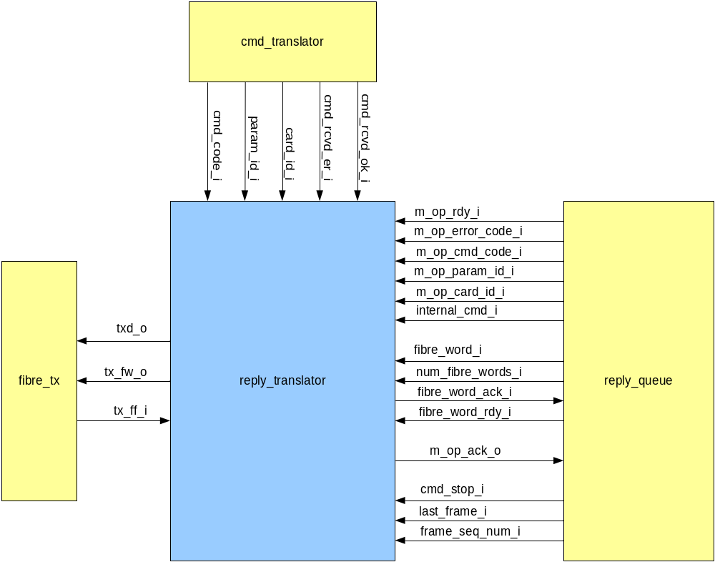
Figure 2: Data flow for reply_translator

Block Interfaces

Interface Signal Description
- Interface Signals
Signal | Description | Direction
Global Signals
clk_i | Global clock signal | in
rst_i | Global asynchronous active-high reset | in
Signals to/from fibre_tx
txd_o  (7..0) | Byte wide data input to the transmit FIFO fibre_tx_fifo. All replies or data frames are written as a byte stream to the fifo. | out
tx_fw_o | When this signal is asserted high txd_o is written to the FIFO fibre_tx_fifo. | out
tx_ff_i | Asserted high when fibre_tx_fifo is full. If asserted then reply_translator will not write any data to the FIFO. | in
Signals to/from cmd_translator
cmd_rcvd_er_i | This is asserted high by cmd_translator when a fibre command is received with a checksum error. When this occurs reply_translator must prepare an appropriate error reply and write it to the transmit FIFO. | in
cmd_rcvd_ok_i | This is asserted high by cmd_translator when a fibre command is successfully received. If when asserted, cmd_code_i indicates that the received command is start_application or reset hen a success reply is immediately packaged and written to the transmit FIFO. | in
cmd_code_i  (15..0) | This is the fibre command code word. It is returned to the RTL PC in the reply packet. It is also used to determine if the received command was a start_application or reset command. It must be valid when cmd_rcvd_ok_i or cmd_rcvd_er_i is asserted high. | in
param_id_i  (15..0) | This is the command parameter ID word. It is returned to the RTL PC in the reply packet. It must be valid when cmd_rcvd_ok_i or cmd_rcvd_er_i is asserted high. | in
card_id_i  (15..0) | This is the command card ID word. It is returned to the RTL PC in the reply packet. It must be valid when cmd_rcvd_ok_i or cmd_rcvd_er_i is asserted high. | in
Signals to/from
reply_queue
m_op_rdy_i | This is asserted high by reply_queue whenever it wants to inform reply_translator that a macro operation has been completed. Normally this results in a fibre packet being written to the transmit FIFO. | in
m_op_ack_o | This is asserted to acknowledge the completion of a m_op_rdy_i instruction from reply_queue. | out
m_op_cmd_code_i | m_op_cmd_code_i is a 3bit vector field used to determine the command that has just been completed. There is a distinct code for all of the five commands and separate code to indicate that a data frame is ready to be packaged. m_op_cmd_code_i becomes valid when m_op_done_i is asserted and should hold until m_op_ack_o is asserted. | in
m_op_error_code_i | The value of this field determines if the m_op command was completed successfully or in error. A zero value indicates success and a non-zero value indicates an error. When in error this word is return in word 3 or the reply packet (for ST, RB and WB commands). | in
m_op_param_id_i | This is the parameter id of the completed m_op. | in
m_op_card_id_i | This is the card id of the completed m_op. | in
fibre_word_i  (31..0) | This field is used by reply_queue to transfer words 3→N+2 of completed ‘read_block memory’ macro ops, and the pixel data of completed ret_data macro ops. The number of words to be read via this field is provided on ‘num_fibre_words_i’. When a word is ready to be read read reply_queue asserts ‘fibre_word_rdy_i’. Once read reply_translator asserting ‘fibre_word_ack_o’ to make the next word available. | in
fibre_word_ack_o | This is asserted high after each word is read via ‘fibre_word_i’. | out
fibre_word_rdy_o | This is asserted by reply_queue when a word is ready to be read from ‘fibre_word_i’. | out
num_fibre_words_i  (31..0) | This value indicates the number of words that reply_queue has to clock out of fibre_word_i. This will always be 0 for write_block memory, and stop_application commands, and in the range 1..58 for read_block_memory commands. For frame data is will be equivalent to the size of the data frame (minus the checksum word, and status block info). | in
cmd_stop_i | This signal is asserted by reply_queue if the completed DATA macro op is that last frame forced by a STOP command. If high bit #1 of the frame status word is set. | in
last_frame_i | This signal is asserted by reply_queue if the completed DATA macro op is the last frame It high bit #0 of the frame status word is set. | in
frame_seq_num_i | This is the frame sequence number and is returned to the linux PC as part of the data frame (word 2) | in

Interface Protocol and Timing

High-Level Description

State Machine Description
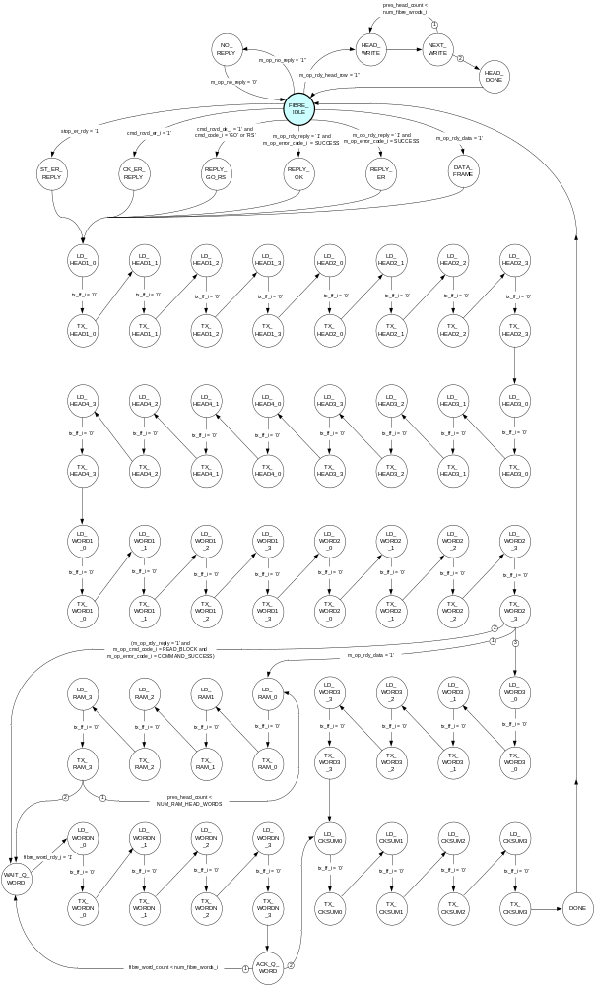

The main core of reply_translator is a Finite State Machine (FSM), which packages up reply and data packets and writes them to the transmit FIFO fibre_tx_fifo. The state transition diagram for this FSM is shown above.

Files of the Block

Source Code

reply_translator.vhd

Header Code

issue_reply_pack.vhd

